Name:______________________________________ Date: ____________ Period: ____
Lesson 2.2.4 Homework Problems 2-79 to 2-84
2-79. Find the value of each of the following expressions. Use a tile diagram or a number line to help you, if you need it.
a. 3(4) b. 4 + 11 + (–4)

c. 3.2(2) d.

e. f. 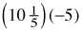

2-80. Use the Distributive Property to rewrite each of the following products as sums, and then calculate the value, as shown in the example below.
Example: 4(307) = 4(300) + 4(7) = 1200 + 28 = 1228
a. 9(410)

b. 6(592)

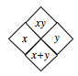
2-81. Complete each of the Diamond Problems below. The pattern used in the Diamond Problems is shown at right.
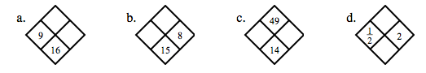

2-82. Complete each of the portions webs below.
a. 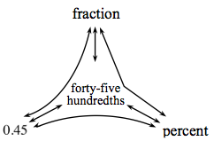 b. 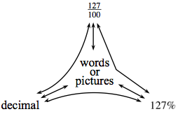

2-83. Camille had a very fun birthday party with lots of friends and family attending. The party lasted for 3 hours. She and her friends played games for of the time, ate pizza and cake for 50% of the time, and spent the remainder of the time opening presents. Draw a diagram and make calculations to show the amount of time spent opening presents.

2-84. Jahna measured the heights of the sunflowers growing in her backyard. Here are the heights that she found (in inches): 34, 48, 52, 61, 76, 76, 61, 84, 61, 39, 83, 61, 79, 81, 56, and 88. Find the mean and median of the heights.
a. Find the mean and median of the heights.

Mean: ________________
Median: ________________

b. Create a histogram to represent this data. Your histogram should have four bins, each with a width of 15.

